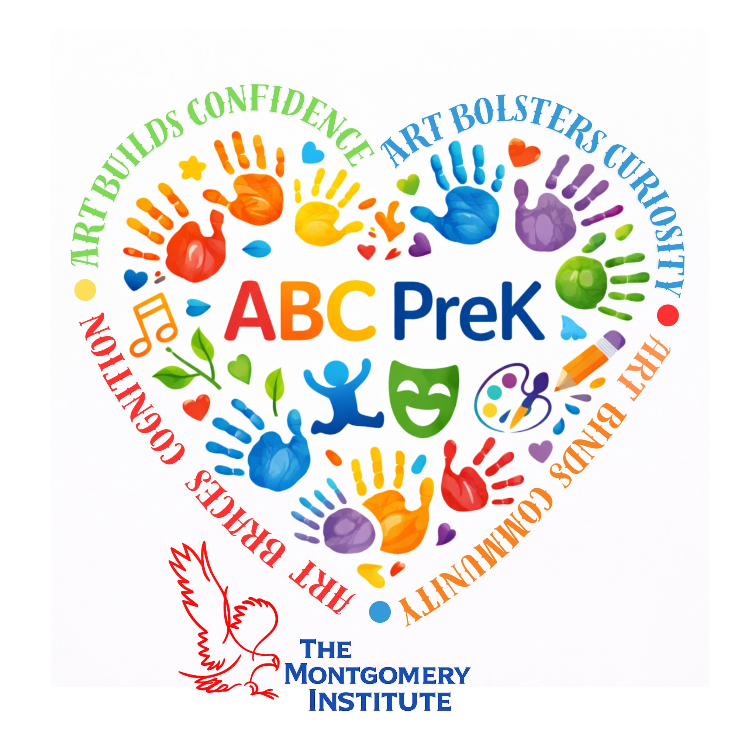 | Learning Plan Guide:  Arts Integration  The Montgomery Institute • ABC PreK Program

Lesson Title: | Blowin’ in the Wind: Songwriting for Change

Arts Content Focus:  Music — Songwriting/Composition | Non-Arts Content Focus:  English Language Arts (Reading Literature, Foundational Skills, Writing, Language)

Lesson at a Glance

Lesson at a Glance | Lesson Summary 2-3 sentence lesson “snapshot”:
 | Using Bob Dylan’s “Blowin’ in the Wind” as a model, students rewrite new lyrics to the song’s familiar melody to address the issue of bullying. Working together, the class brainstorms words and images, counts syllables to fit the existing rhythm, and performs their new verse on guitar, ukulele, and classroom instruments.

Setting the Stage

Setting the Stage | Who & Where
Setting the Stage | Author(s): Richelle Putnam  Cultural Identity of Author(s) — optional: ________________________________  Learning Setting: Classroom  Student Age Range: 4-6th Grade (approximately 10–12 years old)  Time Needed: 60 minutes
Setting the Stage | Lesson Overview / Context:  Through “Blowin’ in the Wind,” students re-write the song to approach and address an issue relevant to their lives — in this case, bullying. The lesson can be adapted to other subjects, such as science or history, by changing the issue addressed in the new lyrics.

Learning Goals

Learning Goals | Big Ideas & Key Concepts What concepts matter most to my students? | Skills & Thinking Arts and non-arts content standardsor bench-  marks: | Looking for Learning What will we see and hear that shows student learning?
Learning Goals | Big Idea:  Songwriters use rhythm, rhyme, and word choice to give voice to real issues and to move listeners to think and feel differently about the world around them.  Key Concepts:  - Rhythm, syllable, and beat  - Rhyme, meter, and theme  - Hook, motivation, chorus, and verse  - Resolution  Essential Question:  How can songwriters use words, rhythm, and sound to speak up about an issue that matters to them? | ARTS STANDARDS  MS Arts Learning Standards for Music (2017)  MU:Cr1.1.5 — Explore musical ideas connected to social purposes.  MU:Cr2.1.5 — Document and perform rehearsed musical ideas.  MU:Cr3.1.5 — Revise draft lyrics based on feedback.  MU:Cr3.2.5 — Present the new verse, connecting to its intent.  ACADEMIC STANDARD  MS CCR Standards for English Language Arts, Grade 5  RL.5.2 — Determine a theme from details; summarize the text.  RF.5.3a — Decode unfamiliar multisyllabic words.  W.5.2c, W.5.3d — Link ideas with linking words; use concrete, sensory words.  L.5.3, L.5.5, L.5.5a — Use language effectively; interpret similes and metaphors.  INTEGRATE OBJECTIVE:  Students choose words that build story through character, conflict, and resolution while shaping rhythm and sound — applying songwriting craft and literacy skills to address a real issue. | We will SEE students:  - Brainstorming and choosing words that describe a bully’s actions  - Counting syllables on the board to fit new lines into the song’s rhythm  - Sharing instruments and performing their verse with the group  We will HEAR students:  - Discussing issues like bullying and offering ideas during class conversation  - Reading their new verse aloud, checking that words fit the beat  - Singing and playing their new verse to “Blowin’ in the Wind” as a class

Learning with Students — Lesson Step-by-Step

Time | Teacher Script & Actions | Looking for Learning What do you want students to know and do?
Step 1  10 min | Teacher Script & Actions:  Engage students (the “hook”) by introducing “Blowin’ in the Wind” and presenting a slideshow that explores issues kids dealt with in the past and issues kids deal with today, such as bullying. | Looking for Learning:  Students will SEE:  Students engaged with the slideshow, watching closely and reacting to the issues presented.  Students will HEAR:  Students naming examples of bullying and sharing personal connections to the topic.
Step 2  15 min | Teacher Script & Actions:  Build knowledge: teaching artist and students brainstorm the actions of a bully and the specific words that best describe those actions, building a class word list. The teaching artist models the experience with an example verse, using guitar/ukulele. | Looking for Learning:  Students will SEE:  Students contributing words to the class brainstorm list and watching the teaching artist model an example verse on guitar/ukulele.  Students will HEAR:  Students calling out words and phrases describing a bully’s actions, and the teaching artist’s example verse performed live.
Step 3  15 min | Teacher Script & Actions:  Guide the practice: students create sentences from the brainstormed words to write a new verse on the board. As a class, count the syllables in the new lines to be sure they fit the rhythm and beat of “Blowin’ in the Wind.” Encourage metaphors and similes as words are chosen for sound and meaning. | Looking for Learning:  Students will SEE:  Students writing new lines on the board and marking syllable counts to test the fit against the song’s rhythm.  Students will HEAR:  Students counting syllables aloud and proposing metaphors and similes for the new verse.
Step 4  15 min | Teacher Script & Actions:  Pass out guitar, ukulele, and classroom instruments so students can share in performing both the teaching artist’s example verse and the new verse they wrote together about bullying. | Looking for Learning:  Students will SEE:  Students sharing instruments and following along with the lyrics as the group performs.  Students will HEAR:  The class singing and playing the original verse and their own new verse together to “Blowin’ in the Wind.”
Step 5  5 min | Teacher Script & Actions:  Close with reflection: discuss how the repetition of words draws the listener’s ear, how hard and soft sounds relate to the power of a word, and how syllables create the beat. Assess learning by observing participation, affirming successes, and correcting through discussion. | Looking for Learning:  Students will SEE:  Students participating in the closing discussion and reacting to teacher feedback.  Students will HEAR:  Students explaining how word sound and syllables shaped the rhythm and message of their new verse.

Related Resources & Materials

Materials Needed:

- PowerPoint lesson slides
- Guitar, ukulele, and classroom instruments
- MP3 recording of “Blowin’ in the Wind”
- Whiteboard or chart paper for the class word list and new verse

Extension Resources:
Easy Song Writing — easy-song-writing.com/articles/songbasics.asp; The Muse’s Muse — musesmuse.com; Flocabulary, “Tell a Story” — flocabulary.com/warp/tell-a-story. Students can record or video themselves singing their new song and playing instruments, create an illustrated songbook, or develop a tableau representing the song’s main idea. This lesson can also be adapted to other subjects, such as science or history, by changing the issue addressed in the lyrics.

After Teaching — Reflection on Learning

Reflection on Learning What did students say and do to show learning? Where were students successful? What were some barriers and challenges? | Next Steps How will you celebrate student successes? How will you address identified barriers and challenges?
What did students say and do to show learning? | How will you celebrate successes and address barriers?

Standards Alignment Summary

Arts Standards Addressed | Academic Standards Addressed
- MU:Cr1.1.5  - MU:Cr2.1.5  - MU:Cr3.1.5  - MU:Cr3.2.5 | - RL.5.2; RF.5.3a  - W.5.2c; W.5.3d  - L.5.3  - L.5.5, L.5.5a
Integrated Objective:
Students will write and perform an original verse to “Blowin’ in the Wind” that addresses bullying, demonstrating both songwriting craft (rhythm, rhyme, word choice) and grade-level literacy skills (theme, figurative language, precise word choice) in service of a single, integrated piece of creative work.

